**NAME:P V NAVI KISHORE**

**REG.NO.:192111220**

**CODE:CSA1366**

**EXPERIMENT:2**

**AIM:** To design NFA to accept aaaaaa.

**PROCEDURE:**

1. Select two states one as initial and another as final state.
2. Join the states using edges with directioons
3. Select the edges as a or b or c.
4. Start the stimulation and give the input.

**DESIGN AND OUTPUT:** 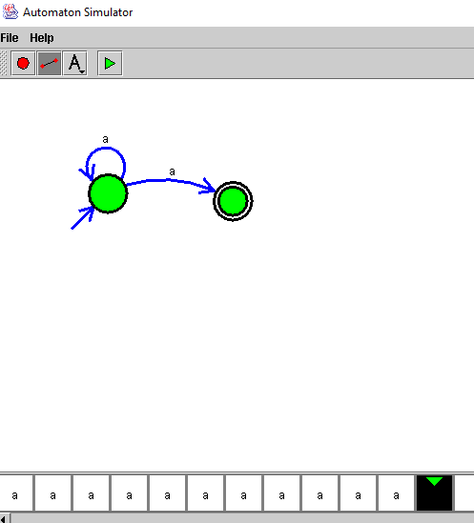

**RESULT:**

Therefore in the stimulation NFA design accepts the input aaaaaa.